Deployment Architecture Design Summary

____________________________________________________________

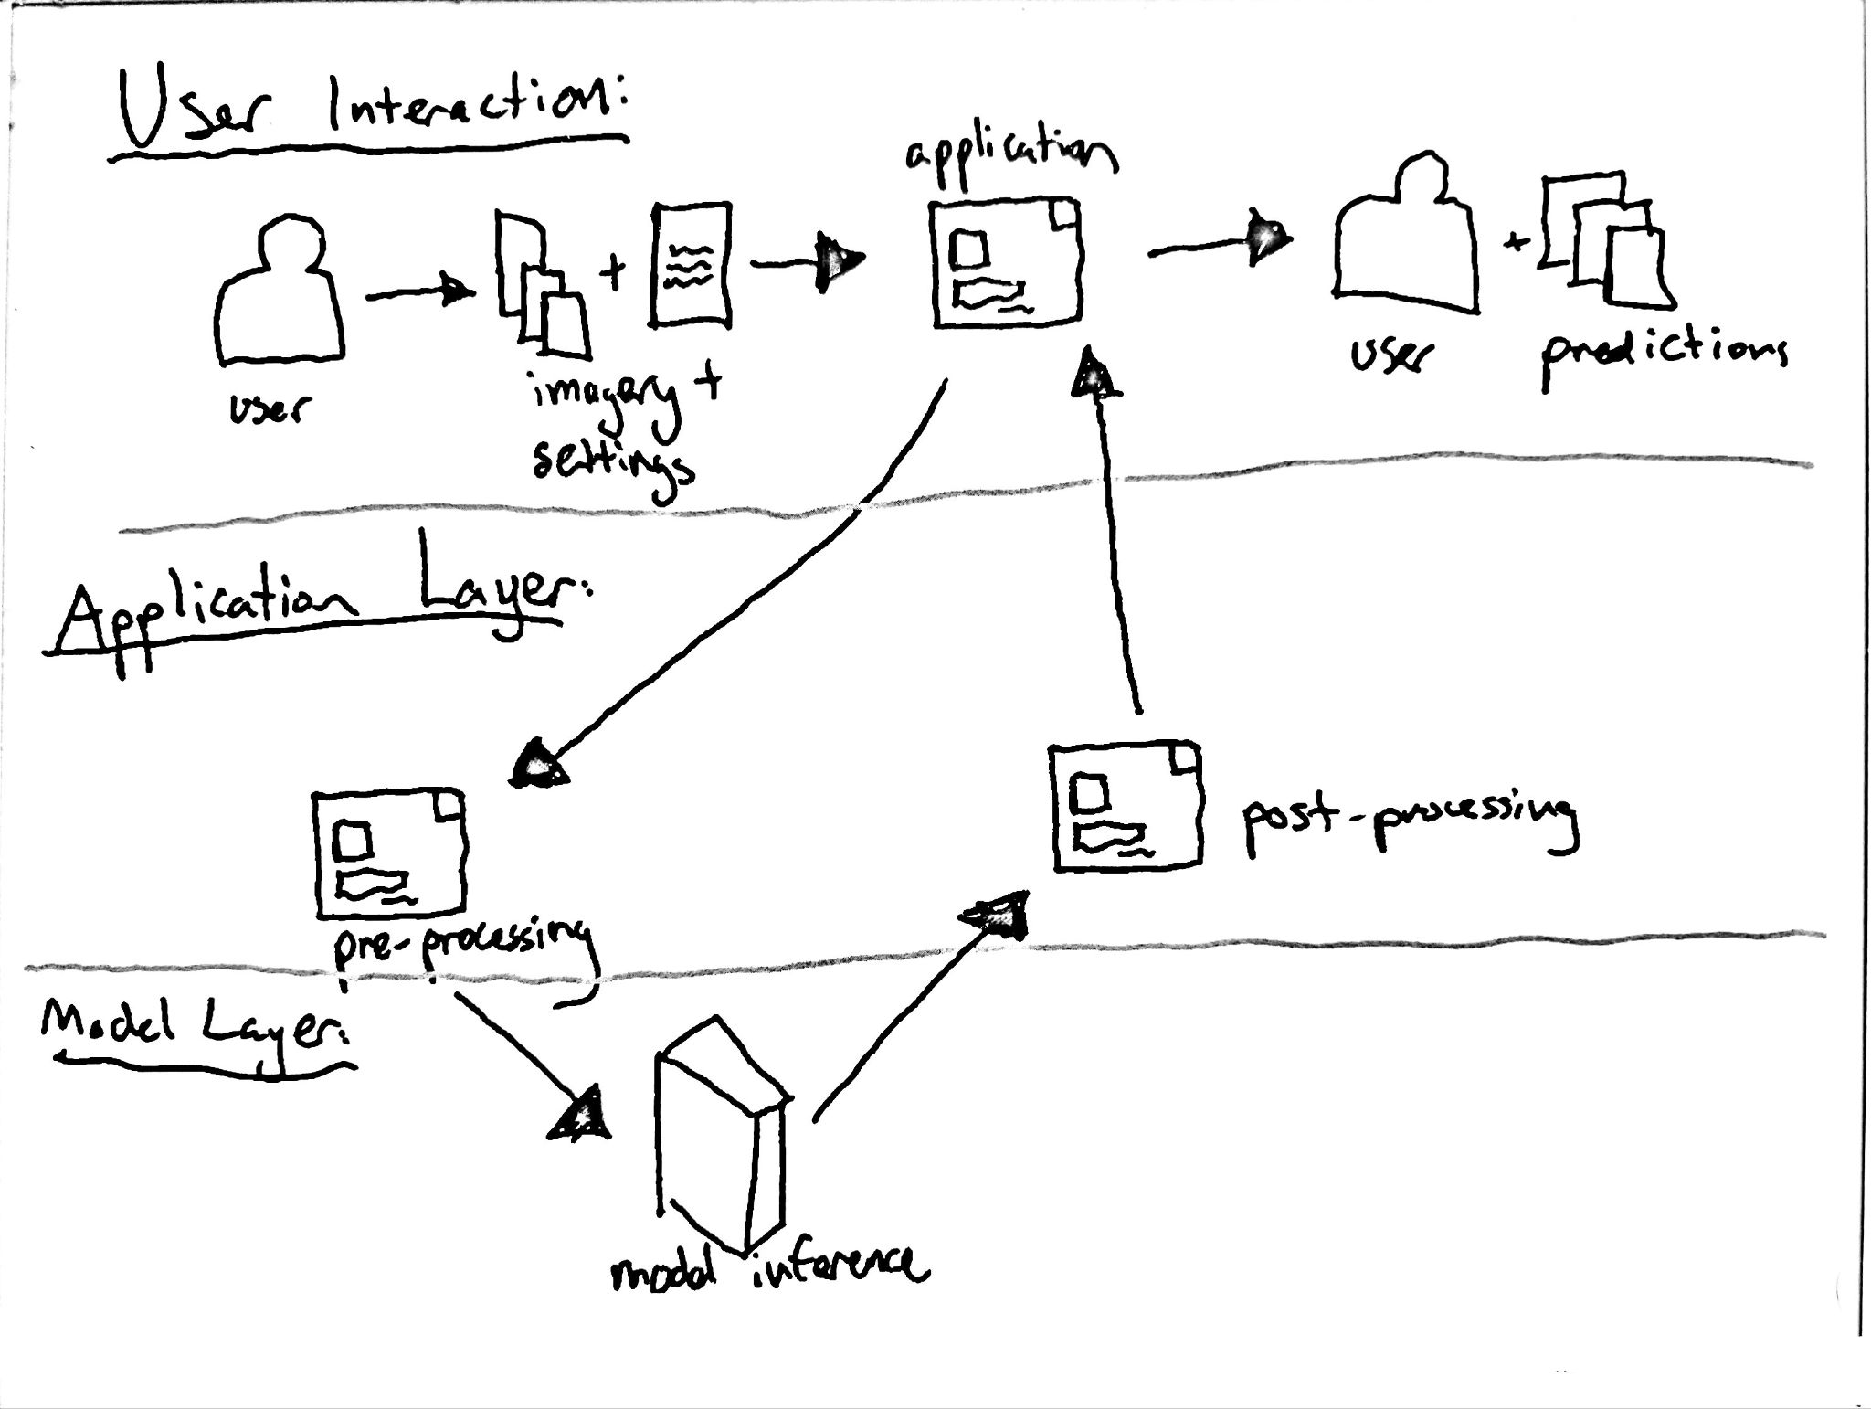
Figure 1: Diagram illustrating a simplified version of the flow of data through the Model Deployment Architecture

Introduction

The diagram above shows a simplified form of the flow of information in this proposed system. The process begins when a user supplies imagery and their desired settings to the application. The application will take this imagery and perform pre-processing in order to pass it along to the model. The model will make its predictions on the imagery and return the probability maps for each image. The application will receive these and apply necessary post-processing to meet the user’s specifications regarding thresholding and the creation of additional overlay imagery. The final step takes place when the user receives the predictions and imagery they had selected for.
In the sections below, I will discuss the specifics of each component of this deployment architecture.

Components and Key Considerations

Major Components, Inputs, and Outputs
The system is composed of three major components:
- Semantic Segmentation Model: A UNet-based deep learning model designed for building footprint extraction.
- Streamlit Application: The web interface where users interact with the model.
- Cloud Hosting Deployment (Streamlit Cloud): Both the application and model are hosted on the cloud for real-time inference.
Inputs:
- Imagery: The user uploads Sentinel-2 satellite imagery (either single images or a time series). The system will accept common image formats such as .tiff and .png. Since the model processes these images by converting them to numpy arrays, the file format is less critical, allowing multiple formats ensures ease of use.
- Settings: The user may select whether or not to threshold the prediction maps. If thresholding is selected, the user can specify a value between 0 and 0.99. The threshold will be applied before producing binarized prediction map images.
Outputs:
- Prediction Maps: After processing, the system outputs probability prediction maps that highlight building footprints. These maps can be downloaded by the user.
- Overlay Imagery (Optional): Users can opt to receive an overlay image, where the prediction map is layered over the original satellite image. This provides additional clarity for interpreting building detection.

Data Storage
Data is stored temporarily while processing is underway. Uploaded imagery and the corresponding output prediction maps are held in memory or temporary storage during the session. The model itself resides in the cloud (Streamlit Cloud), and no persistent storage of user data is necessary beyond the processing window.

Data Flow Between Components
The user uploads an image through the Streamlit interface. Once uploaded, the Streamlit app sends the image to the hosted semantic segmentation model for processing. The model predicts on the image and returns the prediction maps to the application for post-processing. The final step occurs when the resulting prediction imagery is produced, displayed, and made available to the user.

Model Lifecycle
- Frequency of Retraining: The model does not require frequent retraining. Retraining occurs only when significant new data is gathered (e.g., images covering new terrains) or when a more efficient model architecture is identified.
- Data Required for Retraining: Retraining requires both satellite imagery and building footprint annotations. These datasets are sourced from platforms such as SentinelHub and OpenStreetMap.
- Evaluation of Retrained Models: The retrained model is evaluated using metrics like the Dice Score and ROC-AUC. If it shows significant improvements over the model that is deployed, it replaces the current production model.
- Model Deployment: Deployment is manual for now, but it can be automated in the future using AWS or Google Cloud pipelines. However, given the infrequent need for retraining, manual deployment suffices.
- Model Artifact Storage: Retrained models are stored both locally and in cloud storage (Google Drive, GitHub), ensuring future access and easy rollback to previous versions.

System Monitoring & Debugging
Streamlit Cloud offers basic monitoring and debugging capabilities:
- Logging: Python’s logging library will track key events (e.g., image uploads, processing completions). These logs are visible in the Streamlit Cloud console during runtime. While logs do not persist across sessions, the simplest form of persistent logging would involve writing log entries to a local file or cloud storage (e.g., AWS S3 or Google Drive), then periodically deleting old entries.
- Error Tracking: Runtime errors will be captured in logs, enabling real-time diagnosis through the Streamlit Cloud interface. Long-term logging persistence can be considered later, but for now, monitoring within the active session is sufficient.

Error Handling & Outage Response
The system has been designed to gracefully handle errors and outages:
- Error Handling: Potential issues (such as file upload failures or model inference errors) will be caught using considerate design for potential issues and usability. The app will display clear error messages using st.error() to guide users through potential solutions.
- Fallback Mechanisms: In the case of inference errors, users will be notified and prompted to try different inputs. A basic fallback response will be provided when necessary.
- Outage Handling: The system relies on Streamlit Cloud’s uptime and stability. Given the simplicity of the deployment, no additional redundancy mechanisms are currently planned. If required in the future, a backup deployment could be implemented in another cloud environment.

Tools & Technologies
The system is built using the following technologies:
- Semantic Segmentation Model: A variation of a UNET+VGG16 backbone built in TensorFlow for semantic segmentation of a binary classification task.
- Streamlit Application: Built using Streamlit and hosted on Streamlit Cloud, with the repository stored in GitHub.
- Google Colab: Utilized for initial model training.
- Google Drive: Used for storing large datasets, including training data and annotations.
- Cloud Hosting: The model and app are hosted on Streamlit Cloud. Future scalability could involve using AWS or Google Cloud if necessary.

Implementation Cost
- Time: The final implementation requires minimal time for setup, as the Streamlit app interacts directly with the hosted model. Assuming no major issues, the setup should take a few hours to a day.
- Money: The current architecture is entirely free. The model can be trained using Google Colab’s free resources, while the app and storage are supported by Streamlit Cloud and Google Drive’s free tiers. If more computational power is needed in the future, AWS or Google Cloud could provide scalable infrastructure. However, that would incur varying costs depending on architecture considerations.
- Resources: The system requires minimal resources unless high-demand scenarios such as GPU inference or real-time high-resolution imagery processing become necessary.

My Final Remarks
This deployment architecture has been intentionally designed with minimal costs in mind, leveraging freely available Sentinel-2 imagery and no-cost cloud services. This ensures the system is accessible to a broad range of users, particularly those in humanitarian organizations, non-profits, and NGOs, who may not have access to extensive resources.
While the current deployment performs the project’s goals for this stage, it is scalable for future demands. If additional computational power or storage is required, services like AWS or Google Cloud can be integrated. However, for now, the system remains cost-efficient and effective for its intended purpose of providing building footprint extraction to a wide audience.
_________________________________________________________________________________________
Pre-Deployment Checklist
Steps:
- Upload Model to Cloud:
  - Store the trained model artifact in Streamlit Cloud and/or Google Drive for easy access by the application.
- Set Up Streamlit Application:
  - Host the Streamlit application and model on Streamlit Cloud.
  - Link the app to the stored model artifact.
  - Implement any necessary user settings (thresholding, overlay options).
- Test Local Deployment:
  - Run the app locally to verify correct functionality, including user uploads, model inference, and output generation.
- Deploy on Streamlit Cloud:
  - Deploy the application to Streamlit Cloud and verify that model inference works for user-supplied images.
  - Confirm that prediction maps and optional overlays are generated based on user input.
- Version Control & Backup:
  - Ensure the application and model are tracked in GitHub for version control.
  - Backup the current model artifact and deployment configuration in Google Drive.
- Monitor Logs and Errors:
  - Review logs via the Streamlit Cloud console for errors or unexpected behavior during usage.
  - Implement basic logging in the application to capture key events and errors.
- Operationalize and Monitor the Deployment:
  - Verify the system is accessible and reliable for users, providing both prediction maps and overlay imagery.
  - Monitor model and app performance regularly, ensuring continued stability.
  - Ensure there’s a manual rollback plan in place, using backups if needed.
- Explore Flexibility:
  - Experiment with different image formats, thresholds, or overlay settings to explore any possible improvements to the user experience or model performance.
- Document Results and Procedures:
  - Ensure the deployment process and results are replicable by anyone who uses the system.

